NaGISA Sampling Protocol
for sandy beach coastal areas
Shoreline
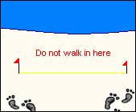
- Cautiously approach your designated site.

Take care not to disturb it by making any unnecessary footprints in the areas where you will be placing your quadrats and taking samples. Never cross the transect line!

- Place the 1x1 meter quadrat (grid) on any random point along the main transect line. Be sure to place the bottom edge of the quadrat along the transect line. Try to avoid allowing too much water wash into the grid. See diagram.
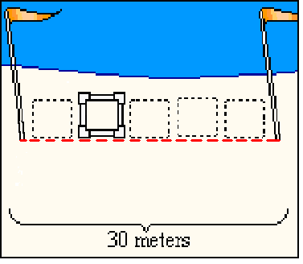
There are two flagged poles on opposite ends of the beach. This line is your main transect line, it stretches 30 meters.

- Next, unscrew the lid of your 2cm Sample jar and place it in the lower right hand corner of your 1x1 meter quadrat grid.

- Send your team’s runner to get the photographer. The photographer will take a picture of the entire frame of the 1x1meter quadrat (grid). Make sure the photographer takes the photograph from directly above the quadrat grid. The grid’s square shape must not be distorted in order to be able to determine the relative size of objects.
Note: You will not be taking samples or organisms from the 1x1meter quadrat (grid).You will only photograph it.

- 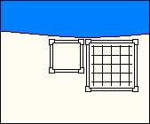Place the 50x50cm quadrat adjacent to the upper left corner of the 1x1meter quadrat (grid). See diagram.

- Kneel down in front of the 50x50cm quadrat. Remove any visible organisms on the surface and place them in the container marked with YOUR CORRECT QUADRAT AND TIME and “Beach 50cm Sample.”

- Next, gently sift through the sand with your hands and look for any additional organisms that may be just below the surface of the sand. Remove these organisms and place them in the correct container as well.
You do not need to “dig” into the sand. Simply glide your hands through the surface to uncover any living organisms that may be hidden in the sand. You should not dig, only sift.

- Once you are done collecting organisms, your team’s runner should immediately bring the container to the ice cooler. Do not place the sample jars in the cooler. Hand it to the specimen curator, and he or she will place it in the correct place.
- Place the 15cm Cylinder next to the upper left corner of the 50x50cm quadrat.
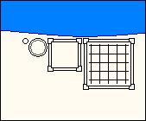
- Next, you need the 2cm Core. Take the 2cm Core and place it next to the upper left of the 15cm Cylinder. See diagram for details.

- Press the 2cm Core down into the sand until the sand reaches the black line that is marked on the side.

- Pull the 2cm Core straight out of the sand.

Holding your thumb over the hole on the top may help keep the contents from falling out of the 2cm Core. If the contents of the core fall out, try to take another sample in an undisturbed area near your first attempt.

- Empty all of the contents from the 2cm Core into the container marked “Beach (SHORELINE) 2cm Core Sample.” Your team’s runner should immediately bring the container to the ice cooler.

If necessary, use the wash bottle filled with salt water to rinse out the insides of the core into the container.
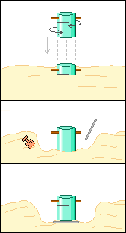
- Now, go back to the 15cm Cylinder that you previously placed. Kneel down next to the Cylinder and press it down in the sand. It is easiest to use a combination of pushing down with a twisting-motion.

**Be sure to push the 15cm Cylinder until the sand reaches the black line that is marked on the side of the cylinder. This line marks a depth of 10cm**

- Next, use the digging tools and your hands to dig away the areas around the 15cm Cylinder. Slide the board or plate underneath the 15cm Cylinder and carefully lift.

- Send your team’s runner to get the photographer. The photographer will take a picture of the entire 15cm Cylinder and its contents while you are holding it in the air.

- Once your cylinder has been photographed, place the entire sample into the large bucket.

If necessary, use the wash bottle filled with salt water to rinse out the insides of the cylinder into the large bucket.

- Add approximately 1 liter of water from the clear plastic jug into the bucket containing the 15cm Cylinder Sample. Then, gently swirl around the sand and water with your hands for 10-20 seconds.

As you swirl the water and sand in the bucket, macro fauna will float to the surface of the water, so be careful not to crush any of the organisms.
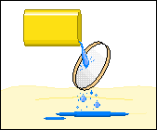
- Next, you need to sift the 1 liter of water through the 500micron net for any macro fauna organisms. Slowly tip the edge of the bucket over the 500micron net and allow only the water to pour into the 500micron net.

You may discard the water that pours through the net. You only need to keep the organisms that do not sift through the net.

- Repeat steps 18 and 19 for a total of 3 times. Once you have swirled and sifted 3 times, you may discard any sand that remains in the plastic bucket.

You may have to make multiple runs back to the ocean when you run out of water while swirling and sifting.
- Next, find the container marked “Beach (SHORELINE) 15cm Cylinder Sample.”
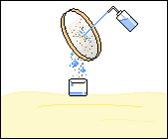
- Take the wash bottle filled with gulf water. Turn the 500micron net over so that the side that holds the organisms is facing the sampling container. Aim the wash bottle at the side of the net that does not contain organisms. Spray the net until all of the visible organisms have been washed into the sampling container. This process is called “back-rinsing.”

You may now discard any remaining sand left in the bucket. The only organisms that you need to keep and place in the container are located on the 500micron net.

- Once you have back-rinsed all of the organisms into the plastic or glass container, your team’s runner should immediately bring the container to the ice cooler.

